MORNING WORSHIP 10/13/19 9:30AM

Come People of the Risen King

WELCOME/CALL TO WORSHIP Ps. 33:20-22

Let God Arise
Shout to the North
Because We Believe
Stand

SCRIPTURE READING & PRAYER TIM KLEIN

1 Pet. 2:1-12

GREETING TIME/CHILDREN’S CHURCH

Firm Foundation
All to Us

SERMON CHRIS TERRY

Rev. 3:14-22 – A Church of Spiritual Pretenders

ANNOUNCEMENTS DANNIE CLARIDA

Gifts of Worship may be placed in the offering box on the back table.
Nursery is provided for infants – 2yrs.
Children’s Church is provided for ages 2 – 5
Nursery and Children’s Church are located downstairs.
A copy of today’s sermon can be downloaded from our website: www.pioneerbiblechurch.com

SUNDAY SCHOOL

Adults | Chris Terry
3yrs. – 1ST Grade | Rebekah Terry
2nd – 4th Grades  5th – 6th Grades | Anita Martin  Vicki Elmore
7th – 12th Grades | Dave Larson

SUNDAY EVENING ACTIVITIES

Small Groups @ 6:00pm

WELCOME VISITORS

If you are visiting with us this morning, we are grateful that you have joined us. Following the morning service, we invite you to a time of refreshments downstairs. If you have any questions or need any assistance, please see our greeters and they can assist you. If you would like to know more about our church and our ministries, visit our website at www.pioneerbiblechurch.com.

ANNOUNCEMENTS

- Fall Retreat – Join us Nov. 1-3 at Camp Horizon for our Fall Retreat. This year our speaker will be Dave Hintz (pastor @ Flint Hills Bible Church). Don’t miss out on this opportunity for great encouragement from God’s Word and wonderful fellowship as a church family. Details and sign-up sheet are in the foyer. Please see Rebekah Terry for any questions.
CHILDREN’S WORKERS TODAY

Morning Worship Nursery D. Baldwin & M. Crompton
Children’s Church Kirk Hollis
Sunday School Nursery Cara Cassens

CHILDREN’S LESSONS TODAY

Children’s Church – God Judges the nations at Babel
Sunday School – God Preserves His Word

MISSONARY OF THE MONTH

Ryan and Dana Powell – Ryan and Dana are serving in France where they are involved in proclaiming the gospel and helping to plant new churches.

BIRTHDAYS & ANNIVERSARIES

Oct. 1st – Cheryl Chanslor
Oct. 1st – Brian Lucas
Oct. 1st – Samantha Terry
Oct. 11th – Corbin Ross
Oct. 15th – Adriana Martin
Oct. 19th – Vicki Wynes
Oct. 20th – Denise Lawrence
Oct. 24th – Annie Ross
Oct. 29th – Michaela Crompton

Oct. 12th – Gerald & Vicki Wynes (1985)

UPCOMING @ PBC

Oct. 13th – Clarida/Klein Small Group
Oct. 20th – Communion
Oct. 23rd – Terry Small Group
Nov. 1st -3rd – Fall Retreat @ Camp Horizon
Nov. 3rd – Sunday Services @ Camp Horizon

VISITOR INFORMATION

If you are new to Pioneer Bible Church, we are delighted that you are visiting with us. It is our sincere aim to make you feel welcome and to be of help to you in any way we can. Below is information about our church that we hope will help you to familiarize yourself with our church.

Jesus Christ – We are committed to exalting Jesus Christ and expanding His Kingdom as we boldly proclaim the gospel of Jesus Christ, faithfully disciple His people, and gladly obey His Word. 2 Corinthian 5:9,18

Scripture – We are committed to upholding the Bible as God’s inerrant, sufficient, and authoritative Word. Psalm 19:7-11

Preaching & Teaching – We are committed to verse-by-verse preaching of the Scriptures and practical training into how God would have us to live every part of our lives for His glory. 2 Timothy 3:16-4:5

One Another – We are committed to being personally involved in one another’s lives through discipleship, fellowship, and mutual care for one another. Hebrews 10:24-25

Children – We are committed to providing a God-centered children’s ministry that teaches children to know and love God and His Word. Psalm 145:4

Students – We are committed to providing a God-centered ministry to youth that provides practical Christian instruction, godly fellowship, and compassionate outreach designed to develop a love for the Lord and His church. Colossians 1:28-29

Music – We are committed to expressing corporate worship to God with music having lyrics that exalt the character of God and express the truths of Scripture. Colossians 3:16-17

Outreach – We are committed to reaching out in love to our community and around the world with the gospel of Jesus Christ through missionary support, gospel-driven mercy ministries, and personal discipleship. Matthew 28:18-20

For more information about our church, please visit our website at www.pioneerbiblechurch.com

– Pioneer Bible Church –
“We strive to equip believers to think biblically, live godly, and to serve practically like our Lord Jesus Christ.”

Pioneer Bible Church 301 N. 3rd St. Ponca City, OK (580)762-5669 www.pioneerbiblechurch.com
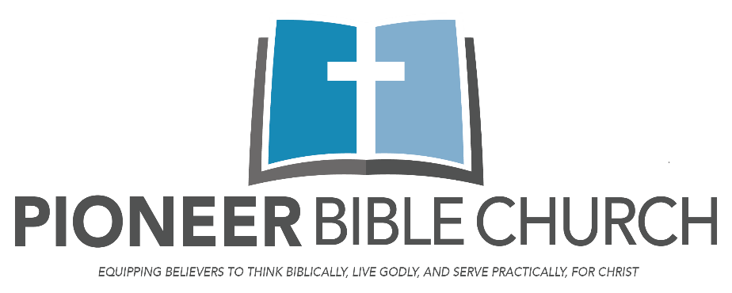
SERMON:

Our soul waits for the LORD;
he is our help and our shield.
For our heart is glad in him,
because we trust in his holy name.
Let your steadfast love, O LORD, be upon us,
even as we hope in you.
Psalm 33:20-22

